2D Graphics

📘 Definition
# Source: AI Source: Provided by: [Data Path: Persons Table -> ID Column: 1, Name_En Column: Motasem Essam] -> From: [ChatGPT] on [5/2/2026]
2D Graphics (Flat Images) are visual elements created on a flat surface with only two dimensions: width and height. They do not have depth, so they appear flat rather than realistic.

🎨 What do 2D graphics look like?
# Source: AI Source: Provided by: [Data Path: Persons Table -> ID Column: 1, Name_En Column: Motasem Essam] -> From: [ChatGPT] on [5/2/2026]
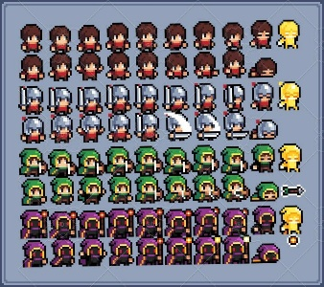
These include:
- Drawings and cartoons
- Logos and icons
- Posters and digital illustrations
- Simple video game visuals

🧠 Simple Example
# Source: AI Source: Provided by: [Data Path: Persons Table -> ID Column: 1, Name_En Column: Motasem Essam] -> From: [ChatGPT] on [5/2/2026]
Games like Super Mario Bros. use 2D graphics where characters move left, right, up, and down—but don’t have real depth.

⚙️ Key Features
# Source: AI Source: Provided by: [Data Path: Persons Table -> ID Column: 1, Name_En Column: Motasem Essam] -> From: [ChatGPT] on [5/2/2026]
- Flat appearance (no 3D depth)
- Easier and faster to create than 3D graphics
- Common in design, animation, and simple games

🚀 In short:
# Source: AI Source: Provided by: [Data Path: Persons Table -> ID Column: 1, Name_En Column: Motasem Essam] -> From: [ChatGPT] on [5/2/2026]
2D Graphics = flat images with only height and width, no depth.

